Chapter 8 Homework Problems

Problem 8.1

A car with an initial velocity of 30 m/s accelerates at a constant rate of 12 m/s2. Find the time required for the car to reach a speed of 60 m/s and the distance traveled during this time.

(Solution: 2.5 sec, distance = 112.5 m)

Problem 8.2

A car traveling 60 miles per hour approaches a fallen log in the road 400 ft away. Assuming the driver immediately slams on the brakes, what is the required rate of deceleration needed to assure the driver does not hit the log?

(Solution: minimum acceleration = -9.68 ft/s2)

Problem 8.3

A train experiences the acceleration over time detailed below. Draw the v-t and x-t diagrams with all key points and equations labeled and determine the total distance traveled by the train.

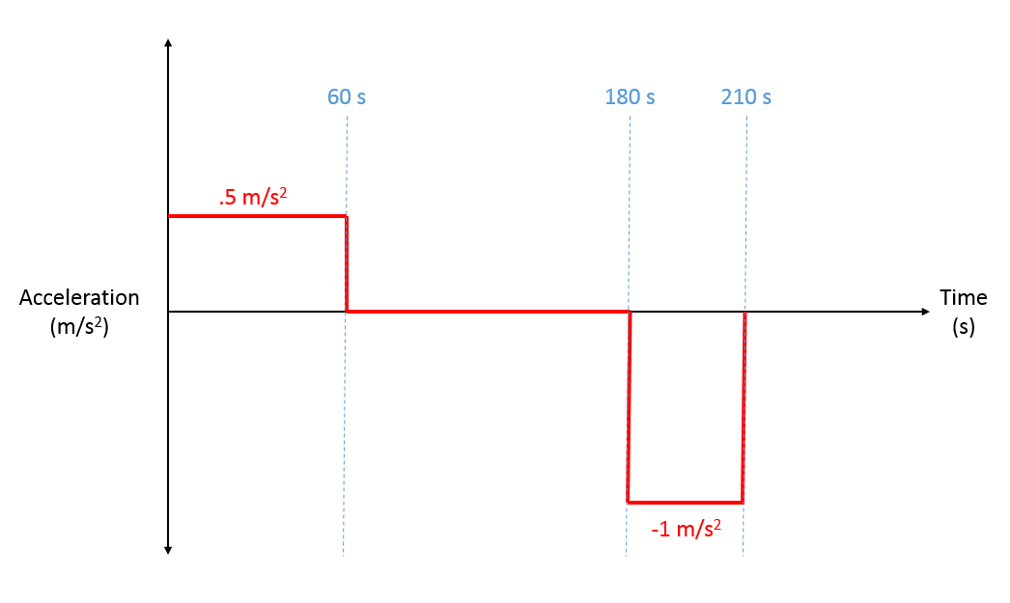

(Solution: total distance = 4950 m + v-t and x-t diagrams)

Problem 8.4

As a roller coaster cart comes into the gate at the end of the ride it goes through two sets of brakes. The velocity over time is shown in the graph below. Draw the a-t and x-t diagrams with all key points and equations labeled. Determine total distance the cart travels during this seven-second period.

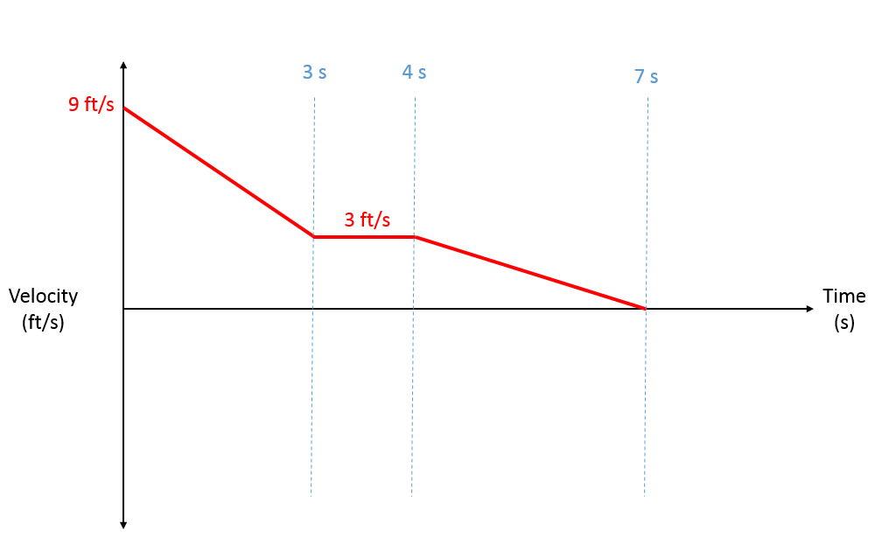

(Solution: 25.5 ft + a-t and x-t diagrams)

Problem 8.5

You launch a water balloon at a 40o angle as shown in the diagram below. A target is 25 feet away and 10 feet off the ground. If we ignore air resistance, what is the initial velocity we should give the water balloon to ensure it hits the target?

(Solution: vi = 39.52 ft/s)

Problem 8.6

A tank fires a round at a 30o angle with a muzzle velocity of 600 m/s. The round is expected to hit a mountainside one kilometer away. The mountainside also has an average angle of 30o. How far up the mountainside will the round be expected to travel before hitting the ground (d) if we ignore air resistance?

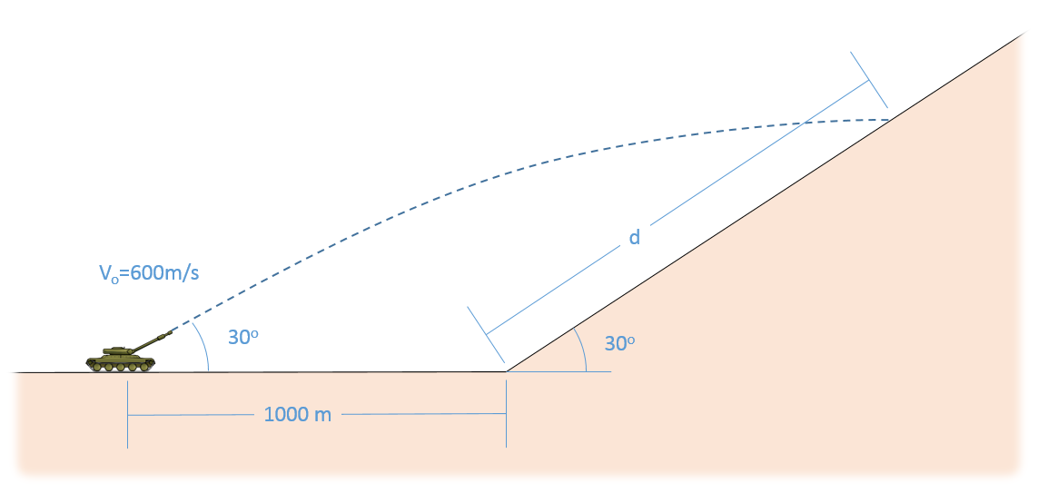

(Solution: d = 5.37 km)

Problem 8.7

A plane with a current speed of 600 ft/s is increasing in speed while also making a turn. The acceleration is measured at 40 ft/s2 at an angle 35o from its current heading. Based on this information, determine the rate at which the plane is increasing its speed (tangential acceleration) and the radius of the turn for the plane.

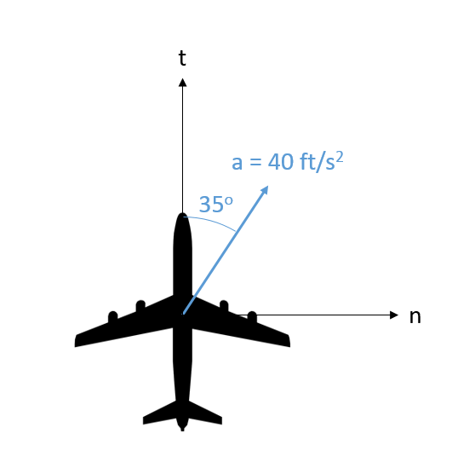

(Solution: at = 32.77 ft/s2 and r = 15,690 ft)

Problem 8.8

A car traveling 25 m/s notices a fallen rock in the road ahead. It immediately begins decreasing its speed at a rate of 4 m/s2 and at the same time begins turning to the left as shown below. If the tires will allow for an overall acceleration of no more than 6 m/s2, what is the minimum radius for the turn before the car will lose grip?

(Solution: )

Problem 8.9

From a space capsule, you observe an asteroid moving by. At one moment it is 5900 meters away at an angle of 61o, three seconds later you observe that the asteroid is 5947 meters away at an angle of 63o as shown below. Using the polar coordinate system, estimate the speed of the asteroid.

(Solution: )

Problem 8.10

A radar station is tracking a rocket with a speed of 400 m/s and an acceleration of 3 m/s2 in the direction shown below. The rocket is 3.6 km away (r = 3600 m) at an angle of 25o. What would you expect , and to be?

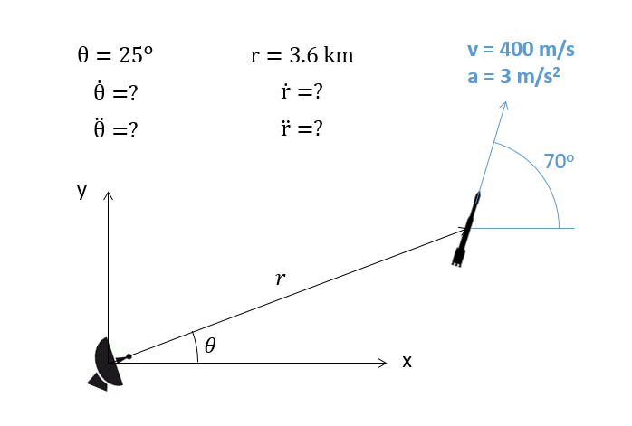

(Solution: = 282.8 m/s, = 24.34 m/s2, = .0786 rad/s, = -.01176 rad/s2)

Problem 8.11

The pulley system below is being used to lift a heavy load. Assuming the end of the cable is being pulled at a velocity of 2 ft/s, what is the expected upwards velocity of the load?

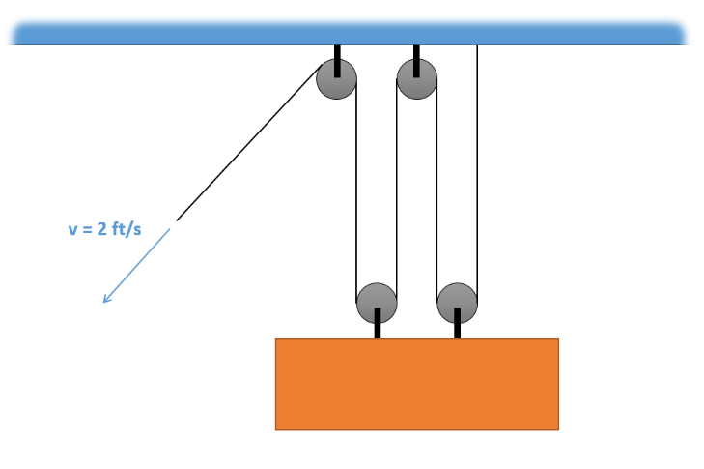

(Solution: vL = 0.5 ft/s)

Problem 8.12

A cable is anchored at A, goes around a pulley on a movable collar at B, and finally goes around a pulley at C as shown below. If the end of the rope is pulled with a velocity of .5 m/s, what is the expected velocity of the collar at this instant?

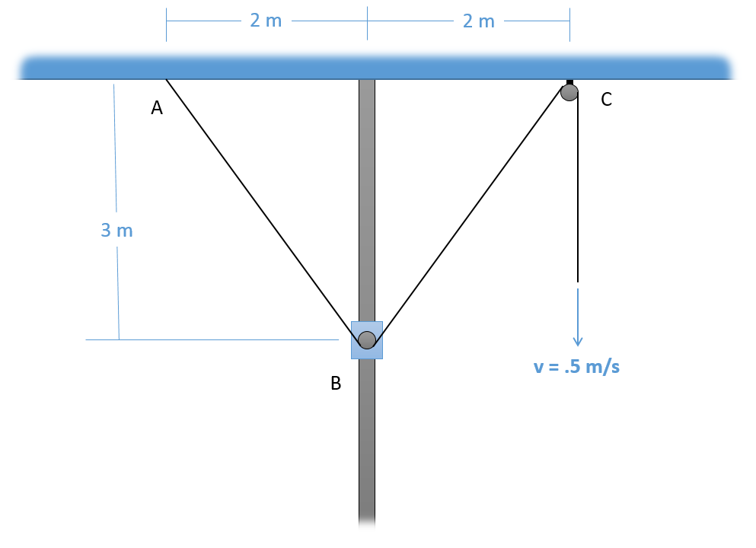

(Solution: vB = 0 .3 m/s)

Problem 8.13

You are driving at a velocity of 90 ft/s in the rain while you notice that the rain is hitting your car at an angle 35o from vertical from your perspective. Assuming the rain is actually coming straight down (when observed by a stationary person), what is the velocity of the rain with respect to the ground?

(Solution: vr = 128.5 ft/s)

Problem 8.14

A plane has a measured airspeed (velocity of plane with respect to the air) of 400 m/s at an angle of 40o, and a measured ground speed (velocity of plane with respect to the ground) of 410 m/s at an angle of 37o as shown in the diagram below. Based on this information, what is the speed and direction of the air with respect to the ground?

(Solution: va/g = 23.4 m/s, 26.26o below the x axis)